
LESSON NOTE | DETAILED EXPLANATORY NOTES

GENETICS AND MOLECULAR BIOLOGY
DNA REPLICATION

GRADE 12- BIOLOGY

■ ■ ■

What is Molecular Biology?
Molecular biology is the branch of biology that studies the molecules responsible for storing, transmitting, and expressing genetic information within living organisms. The most important molecules involved are DNA, RNA, and proteins, which work together to control the structure, function, growth, and reproduction of cells.
One of the central processes studied in molecular biology is DNA replication, the mechanism by which a cell copies its genetic material before cell division. DNA replication ensures that each new cell receives a complete and accurate set of genetic instructions, allowing organisms to grow, repair damaged tissues, and reproduce successfully.
Molecular biology provides the foundation for understanding heredity, gene expression, biotechnology, medicine, agriculture, and modern genetic research. By studying molecular processes, scientists can investigate how genetic information is maintained and how it influences the characteristics and functions of living organisms.

The Core Processes of Molecular Biology
Modern molecular biology focuses on several interconnected processes that govern the flow and use of genetic information:
- Replication - the copying of DNA before cell division.
- Transcription - the process of copying genetic information from DNA into RNA.
- Translation - the process of using RNA instructions to build proteins.
- Gene Regulation - the control of when and how genes are switched on or off.
- Recombinant DNA Technology and PCR - techniques used to copy, analyze, and manipulate DNA in research, medicine, and biotechnology.
Together, these processes explain how genetic information is stored, maintained, and expressed within living organisms.

DNA Replication

Key Learning Outcomes
By the end of this lesson, students should be able to:
- Explain the importance of DNA replication and identify when replication occurs during the cell cycle.
- Define DNA replication and explain how complementary base pairing enables accurate copying of genetic information.
- Describe the roles of key replication enzymes, including helicase, primase, DNA polymerase, exonuclease, and DNA ligase.
- Explain the formation and function of the replication fork during DNA replication.
- Describe how new DNA strands are synthesized in the 5′→3′ direction.
- Distinguish between the leading and lagging strands and explain the formation of Okazaki fragments.
- Explain why DNA replication is described as semiconservative.
- Describe the proofreading process and explain how it contributes to replication accuracy.
- Explain how the principles of DNA replication are applied in the Polymerase Chain Reaction (PCR).
- Discuss the importance of DNA replication in growth, repair, reproduction, and biotechnology.

What is DNA Replication?
DNA replication is the biological process by which a DNA molecule produces an exact copy of itself. During replication, one double-stranded DNA molecule becomes two identical double-stranded DNA molecules, ensuring that genetic information is accurately passed from one cell generation to the next.
Replication is possible because DNA consists of two complementary strands. When the strands separate, each original strand acts as a template for the construction of a new complementary strand. Through complementary base pairing, adenine pairs with thymine and guanine pairs with cytosine, allowing the genetic information to be copied with a high degree of accuracy.
DNA replication occurs during the S (Synthesis) phase of the cell cycle, before a cell undergoes mitosis or meiosis. By completing replication before cell division, the cell ensures that each daughter cell receives a complete set of genetic instructions necessary for survival, growth, and normal functioning.
The process is highly coordinated and involves several specialized enzymes that unwind the DNA molecule, add new nucleotides, proofread the newly synthesized strands, and join DNA fragments together.

Why Does DNA Need to Replicate?
Before a cell divides, it must produce an exact copy of its DNA so that each daughter cell receives the same genetic information as the parent cell. Without DNA replication, newly formed cells would not possess the instructions required to carry out essential cellular activities.
DNA replication is therefore essential for:
- Growth - increasing the number of cells in an organism.
- Repair - replacing damaged or worn-out cells.
- Reproduction - passing genetic information to offspring.
- Genetic Continuity - maintaining the stability of genetic information across generations.
Accurate DNA replication ensures that organisms can grow, develop, reproduce, and maintain their biological functions while preserving the integrity of their genetic material.
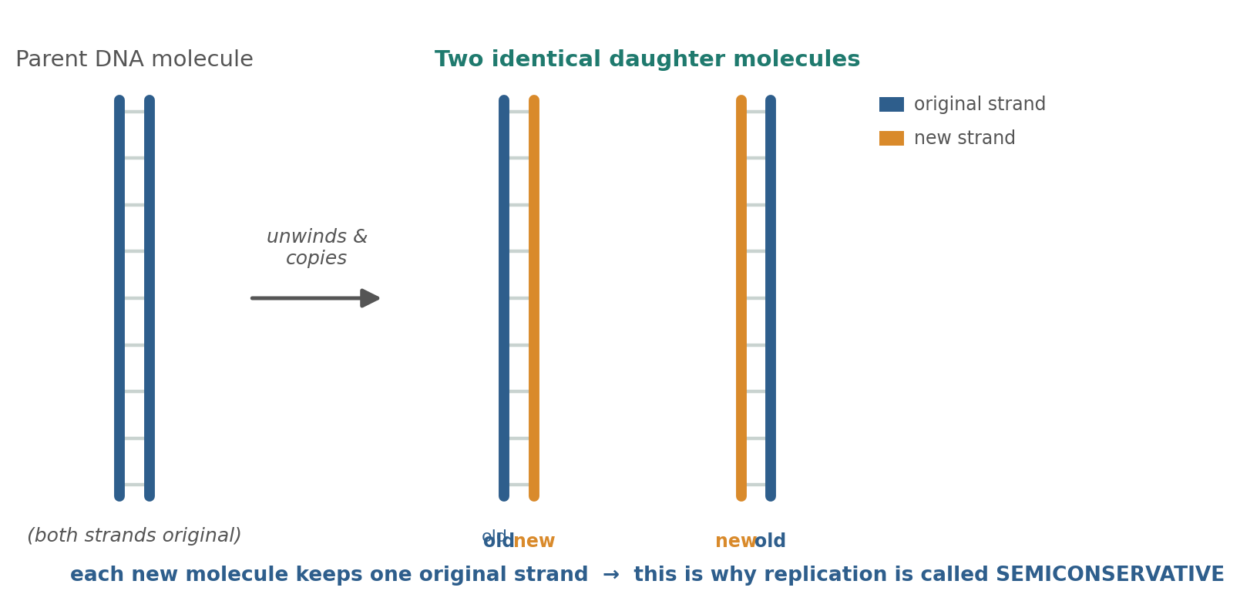

Figure 1: Semiconservative replication - each new molecule keeps one original strand (blue) and one new strand (orange).

DNA Replication - Terminologies and Concepts
DNA replication involves several specialized structures, enzymes, and processes that work together to ensure the accurate copying of genetic information. Understanding these key terms provides the foundation for studying how DNA is replicated within cells.
- Semiconservative Replication: A mode of DNA replication in which each newly formed DNA molecule contains one original (parental) strand and one newly synthesized strand.
- Template Strand: An original DNA strand that serves as the pattern for the construction of a complementary strand during replication.
- Replication Fork: The Y-shaped region formed when the DNA double helix is unwound and the two strands separate.
- Helicase: An enzyme that unwinds the DNA double helix by breaking the hydrogen bonds between complementary base pairs.
- Primase: An enzyme that synthesizes short RNA primers required to initiate DNA synthesis.
- Primer: A short sequence of RNA that provides a starting point for DNA polymerase to begin adding nucleotides.
- DNA Polymerase: The enzyme responsible for synthesizing new DNA strands by adding complementary nucleotides in the 5′→3′ direction. DNA polymerase also performs proofreading to reduce replication errors.
- Leading Strand: The new DNA strand synthesized continuously toward the replication fork.
- Lagging Strand: The new DNA strand synthesized discontinuously away from the replication fork in short segments known as Okazaki fragments.
- Okazaki Fragments: Short DNA segments produced on the lagging strand that are later joined together.
- DNA Ligase: An enzyme that joins adjacent DNA fragments by sealing gaps in the sugar–phosphate backbone.
Together, these structures and enzymes ensure that DNA replication proceeds accurately and efficiently, allowing cells to maintain the integrity of their genetic information.

Key Components of DNA Replication
Term | Function
Semiconservative Replication | Produces DNA molecules with one old and one new strand
Template Strand | Serves as a pattern for DNA synthesis
Replication Fork | Site where DNA strands separate
Helicase | Unwinds the DNA double helix
Primase | Produces RNA primers
Primer | Starting point for DNA synthesis
DNA Polymerase | Synthesizes and proofreads new DNA
Leading Strand | Continuously synthesized strand
Lagging Strand | Discontinuously synthesized strand
Okazaki Fragments | Short DNA segments on the lagging strand
DNA Ligase | Joins DNA fragments together

The Importance of Complementary Base Pairing
Complementary base pairing is the foundation of DNA replication. Because adenine always pairs with thymine and guanine always pairs with cytosine, each original DNA strand can serve as a template for the formation of a new complementary strand.
This precise pairing mechanism ensures that genetic information is copied accurately during replication, helping maintain genetic continuity between parent and daughter cells. Without complementary base pairing, reliable DNA replication would not be possible.

The Replication Fork
DNA replication begins when the enzyme helicase binds to a specific region of the DNA molecule and unwinds the double helix. Helicase breaks the hydrogen bonds that hold complementary base pairs together, causing the two DNA strands to separate.
Regions rich in adenine–thymine (A–T) base pairs are generally easier to separate because A–T pairs are held together by two hydrogen bonds, whereas guanine–cytosine (G–C) pairs are held together by three hydrogen bonds.
As the DNA strands separate, a characteristic Y-shaped structure called the replication fork is formed. The replication fork is the active site where DNA replication occurs. Each separated DNA strand serves as a template strand, guiding the synthesis of a new complementary strand through base pairing.
As helicase continues to move along the DNA molecule, the replication fork progresses, exposing additional template DNA for replication. Multiple enzymes then work together at the replication fork to build new DNA strands and ensure accurate copying of genetic information.

Key Events at the Replication Fork
- Helicase unwinds the DNA double helix.
- Hydrogen bonds between complementary bases are broken.
- The two DNA strands separate.
- A replication fork is formed.
- Each original strand acts as a template for DNA synthesis.
- Replication enzymes begin constructing new complementary strands.
The replication fork serves as the central working region of DNA replication, coordinating the activities of multiple enzymes to ensure that genetic information is copied accurately and efficiently.
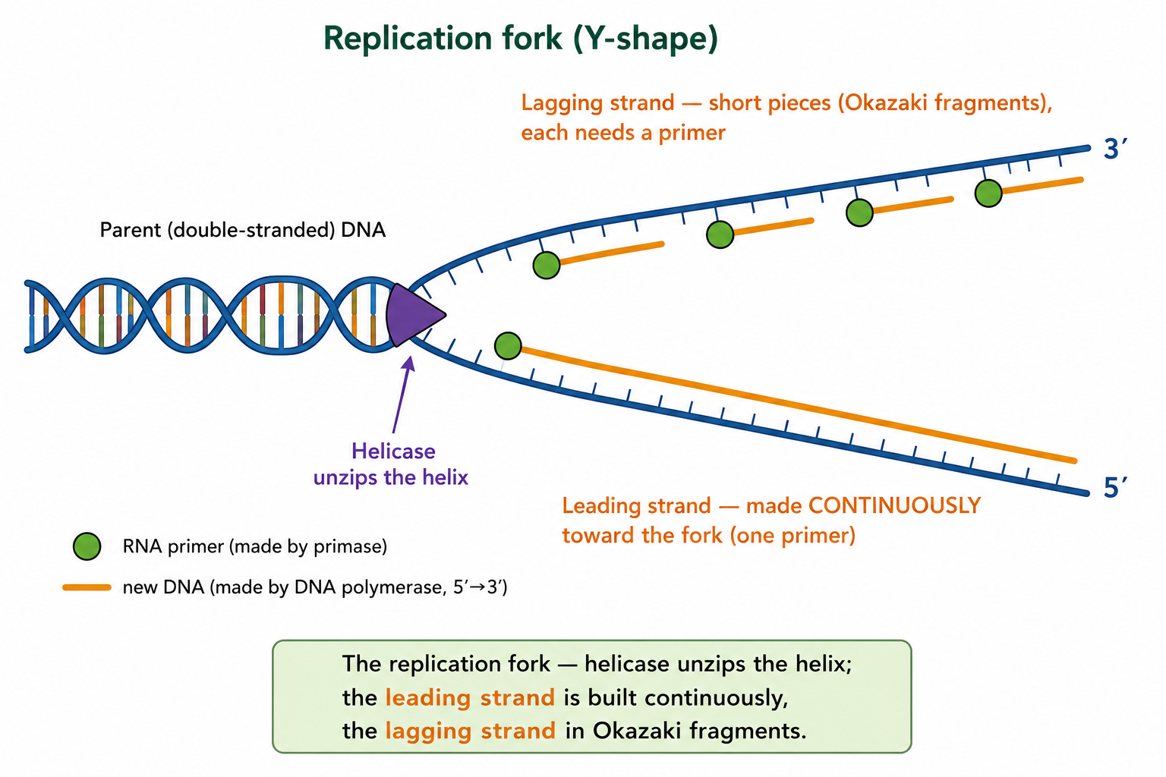
Figure 2: The replication fork - helicase unzips the helix; the leading strand is built continuously, the lagging strand in Okazaki fragments.

Leading and Lagging Strands
Once the DNA strands have separated at the replication fork, new complementary strands must be synthesized. Before DNA synthesis can begin, the enzyme primase produces a short RNA primer, which provides a starting point for DNA polymerase.
The enzyme DNA polymerase then adds complementary nucleotides to the growing DNA strand. However, DNA polymerase can add nucleotides only in the 5′→3′ direction. Because the two original DNA strands are antiparallel, the new strands must be synthesized in different ways.
The leading strand is synthesized continuously toward the replication fork. Because DNA polymerase can move smoothly along the template strand, only a single RNA primer is required to initiate synthesis.
The lagging strand is synthesized discontinuously away from the replication fork. As the fork continues to open, DNA polymerase produces short DNA segments known as Okazaki fragments. Each fragment requires its own RNA primer before synthesis can begin.
After the DNA fragments are produced, the enzyme exonuclease removes the RNA primers. The resulting gaps are filled with DNA nucleotides, and DNA polymerase proofreads the newly synthesized strands to minimize errors. Finally, DNA ligase joins the Okazaki fragments together, producing a continuous DNA strand.

Comparison of Leading and Lagging Strands
Feature | Leading Strand | Lagging Strand
Direction of Synthesis | Toward the replication fork | Away from the replication fork
Synthesis Pattern | Continuous | Discontinuous
Number of Primers | One | Multiple
Okazaki Fragments | Absent | Present
DNA Ligase Required | Minimal | Essential for joining fragments

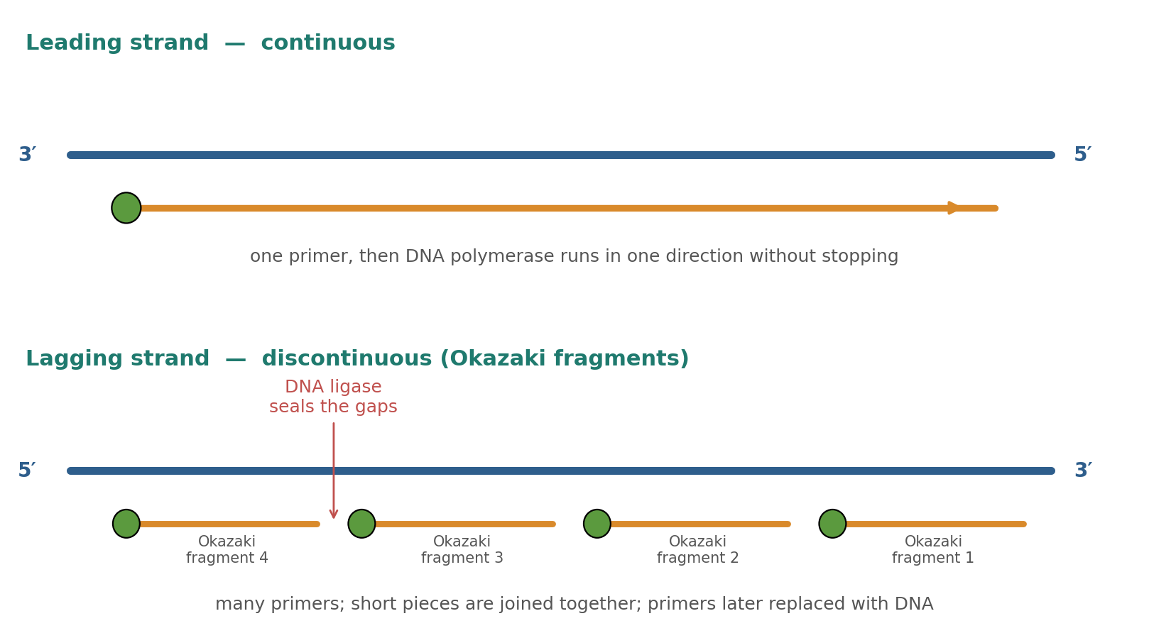

Figure 3: The leading strand is continuous; the lagging strand is built as Okazaki fragments, later joined.

Why are the Leading and Lagging Strands Different?
The leading and lagging strands are formed differently because DNA polymerase can add nucleotides only in the 5′→3′ direction. Since the two template strands run in opposite directions (antiparallel), one new strand can be synthesized continuously, while the other must be produced in short fragments.
This arrangement is a direct consequence of DNA structure and the limitations of DNA polymerase. Despite their different methods of synthesis, both strands are replicated accurately to produce complete copies of the DNA molecule.

Semiconservative Replication
DNA replication is described as semiconservative because each newly formed DNA molecule contains one original (parental) strand and one newly synthesized strand. During replication, the two original DNA strands separate and each serve as a template for the construction of a complementary strand.
As a result, the two daughter DNA molecules are identical to each other and closely match the original DNA molecule. This mechanism ensures the accurate transmission of genetic information during cell division.
The semiconservative nature of DNA replication was demonstrated by the famous Meselson–Stahl experiment in 1958. Their research provided strong evidence that each daughter DNA molecule retains one parental strand and one newly synthesized strand, confirming the model proposed by Watson and Crick.
Semiconservative replication contributes significantly to the accuracy and reliability of genetic inheritance because each original strand serves as a template for the production of a new complementary strand.

Why is Semiconservative Replication Important?
Semiconservative replication helps preserve genetic information by ensuring that each new DNA molecule contains an original strand that acts as a reliable template. This greatly reduces the likelihood of copying errors and allows genetic information to be passed accurately from one generation of cells to the next.

Accuracy: Proofreading
A human cell must copy approximately six billion base pairs during each round of DNA replication. To maintain accuracy, DNA polymerase performs a proofreading function as it synthesizes new DNA strands.
If an incorrect nucleotide is added, DNA polymerase can detect the error, remove the incorrect base, and replace it with the correct nucleotide before replication continues. This proofreading process greatly reduces the frequency of replication errors.
Additional repair mechanisms within the cell further help maintain DNA integrity. Despite these safeguards, some errors may escape repair and become mutations.
Mutations may be:
- Neutral - having little or no effect.
- Beneficial - providing an advantage under certain conditions.
- Harmful - disrupting normal cellular function or causing disease.

Why is Proofreading Important?
Proofreading ensures that genetic information is copied with a very high degree of accuracy. Without proofreading and repair mechanisms, replication errors would accumulate rapidly, increasing the risk of genetic disorders and cellular malfunction.

DNA Replication in Biotechnology: PCR
The Polymerase Chain Reaction (PCR) is a laboratory technique that uses the principles of DNA replication to produce millions of copies of a specific DNA sequence. PCR is often described as molecular photocopying because it rapidly amplifies small amounts of DNA.
PCR involves three repeated stages:
- Denaturation (~94°C) - The DNA double helix separates into single strands as hydrogen bonds between complementary bases are broken.
- Annealing (~50–65°C) - Short DNA primers bind to complementary sequences on the template strands.
- Extension (~72°C) - A heat-stable enzyme called Taq DNA polymerase synthesizes new DNA strands by adding complementary nucleotides.
Each PCR cycle doubles the amount of target DNA present. After 30–40 cycles, millions of copies of the original DNA sequence can be produced.

Applications of PCR
PCR is one of the most important techniques in modern molecular biology and biotechnology. It is used in:
- Medical diagnosis of infectious and genetic diseases.
- Forensic investigations and DNA profiling.
- Paternity testing.
- Scientific and genetic research.
- Biotechnology and genetic engineering.
The ability to amplify DNA quickly and accurately has made PCR an essential tool in medicine, agriculture, biotechnology, and biological research.

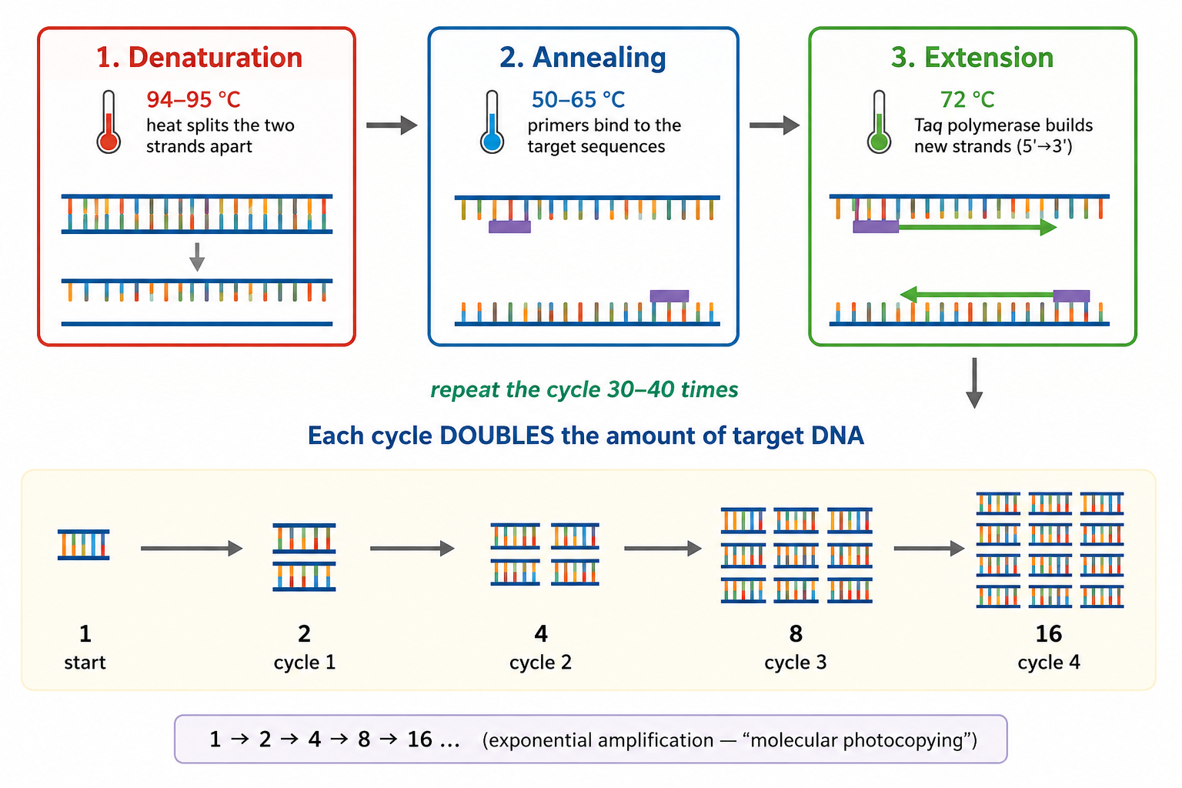
Figure 4: PCR - repeating the three-step cycle doubles the target DNA each time (exponential amplification).

Worked Example - Building the New Strand
DNA replication depends on complementary base pairing and the ability of DNA polymerase to synthesize new DNA strands in the 5′→3′ direction.
Consider the following template strand:
3′ – T A C G G A T – 5′
Using the rules of complementary base pairing:
- T pairs with A
- A pairs with T
- C pairs with G
- G pairs with C
DNA polymerase adds complementary nucleotides to produce the new strand:
5′ – A T G C C T A – 3′
The newly synthesized strand is complementary to the template strand and identical to the original partner strand. This demonstrates how DNA replication preserves genetic information through accurate base pairing.

Key Principle Demonstrated
Template Strand + Complementary Base Pairing → New DNA Strand
This ability of DNA to serve as its own template is the foundation of accurate inheritance and genetic continuity.

Why DNA Replication Matters
DNA replication is one of the most important processes in biology because it ensures that genetic information is accurately copied and passed to new cells and future generations.
- Growth and Repair - New cells require complete copies of DNA in order to grow, replace damaged cells, and maintain normal body functions.
- Heredity - Accurate replication before meiosis ensures that genetic information can be transmitted from parents to offspring.
- Genetic Continuity - Replication preserves the integrity of genetic information across generations of cells, helping maintain stable biological systems.
- Biotechnology - Understanding DNA replication has led to powerful technologies such as PCR, DNA sequencing, genetic engineering, and molecular diagnostics.
- Medicine and Research - Knowledge of DNA replication helps scientists investigate genetic disorders, study mutations, develop treatments, and improve disease detection.

PNG Context Example
Knowledge of DNA replication and PCR has important applications in Papua New Guinea. These technologies can support disease diagnosis, biodiversity research, agricultural improvement programmers, and the study of genetic variation in plants, animals, and microorganisms. Understanding DNA replication helps scientists and healthcare professionals apply modern biological techniques to real-world challenges.
By understanding DNA replication, students gain insight into how genetic information is maintained, inherited, and applied in modern biology, medicine, and biotechnology.

References & Related Documents

Source Documents
- STEM Biology Student Resource Book - Grade 12, Term 1. Module 12.1 Bioinformatics, Topic 1 (Activity 4: DNA Replication) and Topic 4 (PCR). Department of Education, PNG (2021).
- Biology Standards-Based Syllabus, Grades 11 & 12 (PNG SBC 2020) - Strand 2: Life, Unit 2 Genetics; Benchmark 12.2.2.3.

Further Reading & References
- Meselson, M. & Stahl, F. (1958). The replication of DNA in E. coli. PNAS, 44, 671–682.
- Alberts, B., et al. (2002). Molecular Biology of the Cell (4th Ed). Garland Science, New York.
- OpenStax Biology - https://openstax.org/books/biology
- National Human Genome Research Institute - https://www.genome.gov

